1. **Docker images**:  
   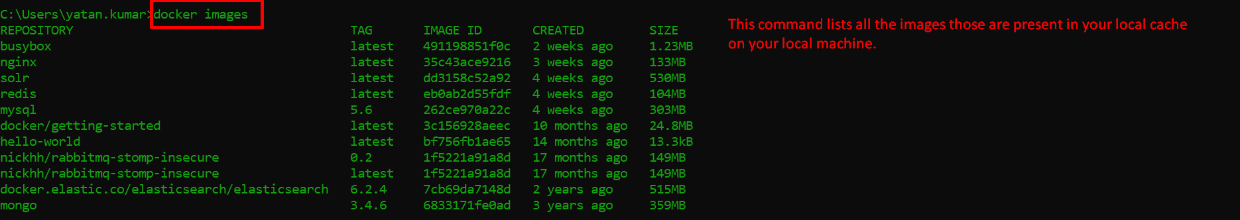
2. **Docker ps:**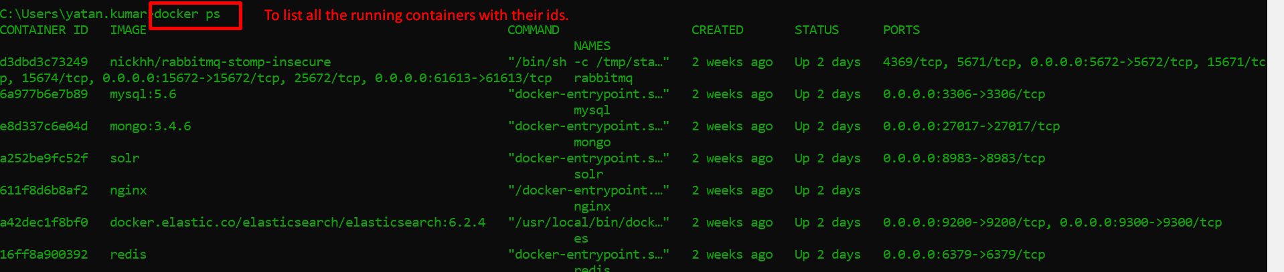
3. **Docker container ls**